
Final REPORT
AIL303m

Apply Machine Learning in Bomberman game using Reinforment Learning

FPT University
HO CHI MINH CITY

June 23, 2025

Leature:
MsC Luu Giang Nam

Student:
Dang Thanh Tuan : SE196418
Ha Quang Hieu : S196477

Contribution:
- Collecting theory and background for project: Hiếu, Tuấn
- Implement, fine turning rule based agent: Tuấn
- Implement Q table: Hiếu, Tuấn
- Implement neural network: Hiếu
- Write, checking report, slide: Hiếu, Tuấn

Content
Content 1
I. Introduction 2
II. Background 3
1. Machine learning 3
2. Reinforcement learning 3
2.1 Markov Decision Process (MDP) 4
2.2 Q-learning 5
III. Method 6
1. Initial 6
2. Environment 7
3. State – Action - Reward 7
4. Rule based agent 8
5. Features 9
4.1. Feature type 1 9
4.2.Feature type 2 11
4.3 Feature Type 3 12
6. Neural Network 13
6.1 Theory 13
6.2 Implement 15
7. Conclution 17

- Introduction
This project applies Reinforcement Learning (RL), specifically Q-learning, to train an agent to play the classic game Bomberman. The goal is for the agent to learn optimal behaviors such as avoiding bombs, defeating enemies, and collecting coins — all through trial and error without human-labeled data.
Bomberman is a grid-based environment that requires real-time decision-making, making it an ideal testbed for RL. In our approach, the agent interacts with the game environment, receives rewards or penalties, and gradually improves its policy over time. We design a custom state representation, reward function, and evaluate performance through win rate and survival time.
This project demonstrates how RL can be used to create intelligent game agents and provides practical insights into applying machine learning in dynamic, rule-based environments.

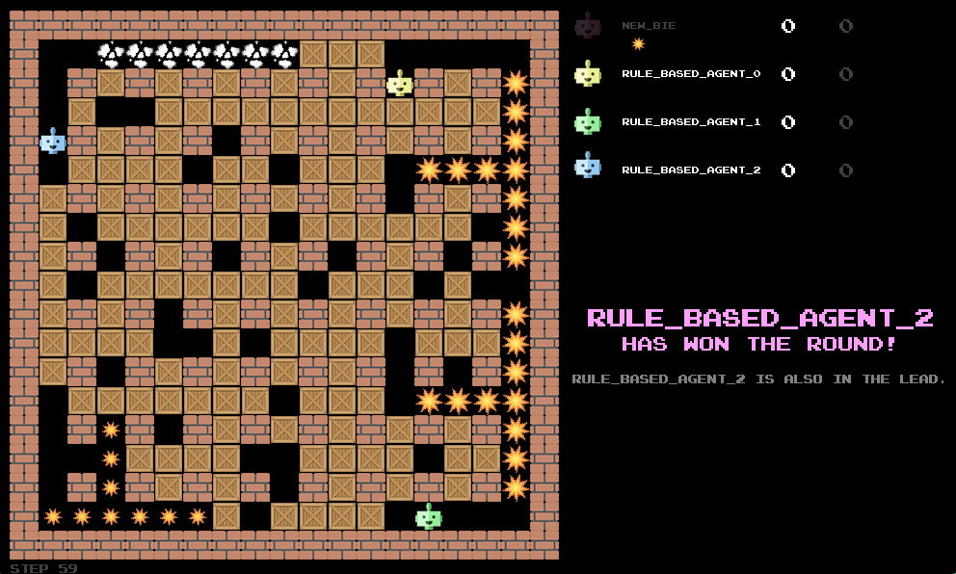
Figure 1: Bomberman game

- Background
- Machine learning
Machine Learning (ML) is a subset of artificial intelligence (AI) that enables computers to learn patterns from data and make decisions or predictions without being explicitly programmed for specific tasks.
At its core, machine learning focuses on building models that can generalize from past experiences (data) to make accurate decisions on new, unseen data.

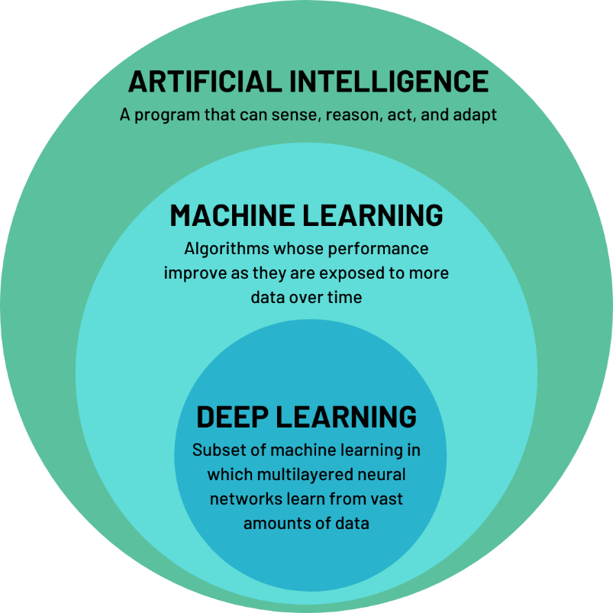
Figure 2: What is machine learning

- Reinforcement learning
Reinforcement Learning is a branch of machine learning where an agent learns how to make decisions by interacting with an environment. The agent observes the current state, selects an action, receives a reward, and transitions to a new state.

The objective of the agent is to learn a policy that maximizes the cumulative long-term reward.
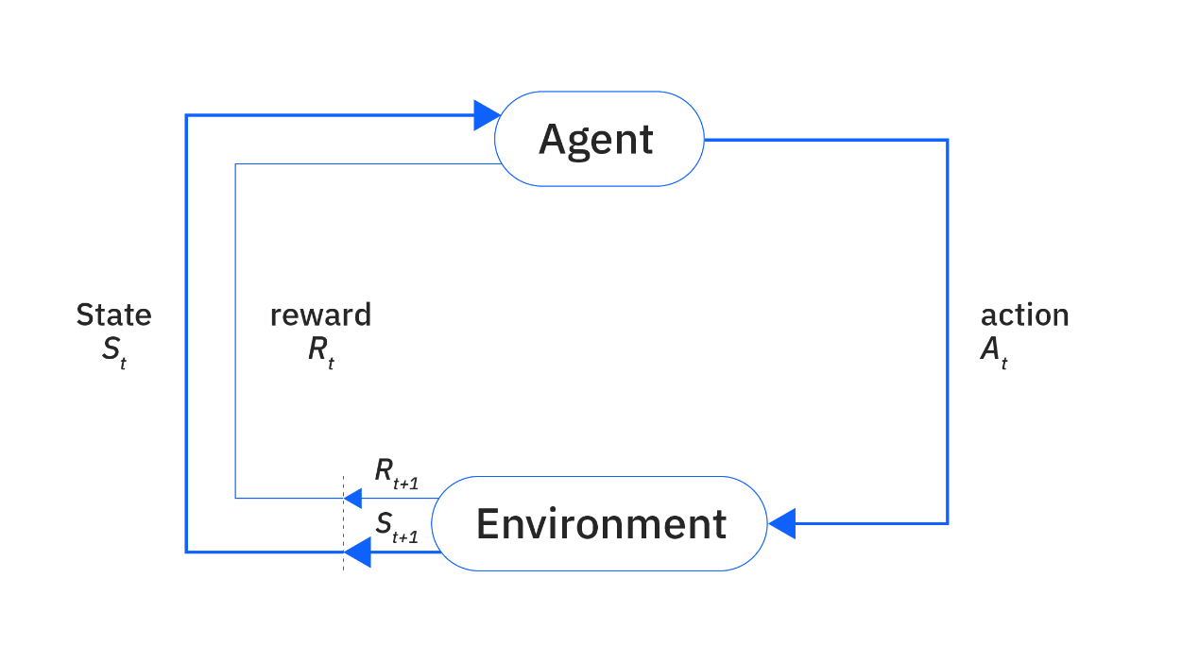
Figure 3: Overview reinforcement learning

  - Markov Decision Process (MDP)
A Markov Decision Process (MDP) is a mathematical framework used to model decision-making in environments where outcomes are partly random and partly under the control of a decision-maker (agent). It provides the foundation for most reinforcement learning (RL) algorithms.
An MDP is formally defined as a tuple:
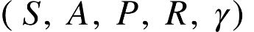
Where:
- : A finite set of states the agent can be in.
- 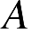: A finite set of actions the agent can take.
- 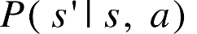: The transition probability — the probability of reaching state s’ after taking action aaa in state s.
- 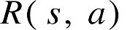: The reward function, giving the immediate reward received after performing action aaa in state s.
- (gamma): The discount factor, 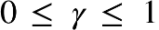, which determines the importance of future rewards.
The Markov property states that the next state depends only on the current state and action, not on the full history. This simplifies the learning and planning process:
This equation represents the probability of transitioning to state s′ given that the agent is currently in state s and takes action a. It captures the stochastic nature of the environment, where the outcome of an action may not be deterministic.
The Markov property allows reinforcement learning algorithms to model the environment effectively without requiring the full history of past interactions. It ensures that the state at time t contains all the necessary information to predict future states and rewards.

  - Q-learning
Q-learning is a widely used model-free reinforcement learning algorithm that enables an agent to learn the optimal action-selection policy in a Markov Decision Process (MDP). It does not require prior knowledge of the environment's dynamics and is capable of learning through direct interaction.
The core idea of Q-learning is to learn a Q-value function, denoted by Q(s,a), which estimates the expected cumulative reward of taking action aaa in state sss, and thereafter following the optimal policy.
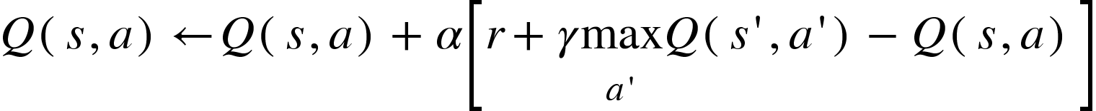
In this formula, Q(s,a) is the current Q-value for action a in state s. s is the current state, a is the action taken, and r is the immediate reward leading to the next state s′. α (learning rate) controls how new information updates Q-values, while γ (discount factor) weighs future rewards. Max a′ ​Q(s′,a′) represents the maximum estimated future reward from the next state s′, guiding the agent towards optimal decisions.
- Method
- Initial
This section details the Artificial Intelligence (AI) methodologies, including traditional Reinforcement Learning (RL) and Machine Learning (ML), employed to develop and train an AI agent to play the Bomberman game. The objective is to create an agent capable of autonomously learning to make optimal decisions within the complex game environment, without relying on Deep Learning models.
The rule of Bomberman:
- Game had been created based on grid (n * n).
- There are three types of tiles in game:
  - WALL
  - CRATE (can be exploded)
  - FREE (can drop bomb here)
- Exploding crate can produce coins.
- Collecting a coin gains the agent one point.
- Each agent has one bomb.
- Blowing up an opponent is worth five points.
- Every episode ends after 400 steps.
- An agent considers to win when it is the last agent standing or keep the highest score when the episode reaches max step.
- But how to the agent know that has it been win?
In the scope of this bomberman, an agent is considered a winner if: he survives until the end or all enemies has been destroyed.
- Parameters
- Epsilon (): Exploration vs. Exploitation
  - Balances discovering new, potentially better paths (exploration) with leveraging current knowledge for rewards (exploitation). A higher ϵ means more exploration.
- Alpha (α): Learning rate
  - Determines how quickly the agent adapts to new information. A higher α means faster, but potentially less stable, learning.
- Gamma (γ): Discount Factor
  - Dictates how much the agent values immediate rewards versus future rewards. A γ closer to 1 emphasizes long-term rewards, encouraging foresight.
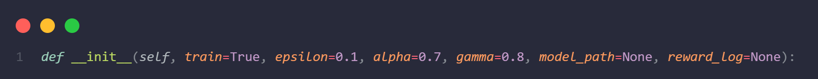
- Environment
The Bomberman game environment is defined by its State (s), represented as a vector of crucial extracted features (e.g., relative positions, bomb and item information) due to the full state space's immense size. Actions (a) include movement and bomb placement. Rewards (r) are designed to encourage desired behaviors such as destroying obstacles, eliminating opponents, and survival.
- State – Action - Reward
The state includes the agent's state and the state of the environment, which is what the environment provides to the agent after each time the agent performs an action and reaches the next state in the environment.
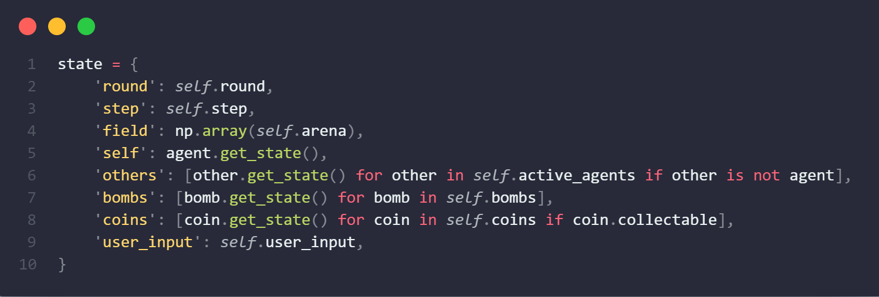

STATE | TYPE | DESCRIPTION
‘round’ | int | The number of rounds since launching the environment, starting at 1.
‘step’ | int | The number of steps in the episode so far, starting at 1.
‘field’ | (width, height) | A 2D array describing the tiles: 1:crates; −1:walls; 0:free tiles.
‘bomb’ | [(int, int), int] | A list of tuples ((x, y), t) of coordinates and countdowns for all active bombs.
‘explosion_map’ | (width, height) | A 2D array, for each tile, for how many more steps an explosion will be present.
‘coin’ | [(x, y)] | A list of coordinates (x, y) for all currently collectable coins.
‘self’ | (str, int, bool, (int, int)) | Information of agent (name, scores, has bomb? , (x, y)).
‘other’ | [(str, int, bool, (int,int))] | Like ‘self’ but for others agent.

Each agent can make 6 actions. Based all algorithm and policy, they can make decision what action to do in state ‘s’.
Based on state ‘s’, apply policy to calculate reward for agent in that step.
Policy using negative reward to present a bad move, in order word, using positive reward to present a good move.
In summary, the State (s) in Bomberman is a comprehensive "snapshot" of the game situation at a given moment, providing all necessary information (map layout, bombs, players, items, explosions) for the AI agent to analyze and make informed action decisions.
- Rule based agent
Instead of requiring a human to play 100, 1000, ... rounds—which is impractical—we implement a rule-based agent using predefined algorithms and policies. This agent serves as the opponent to train our learning agents.
To create an Agent with logical principles, it is necessary to determine 3 factors, in the following order of priority:
Dodge bomb → Plant bomb on target → Picked coin
Note: Target can be (component, crates, coin)
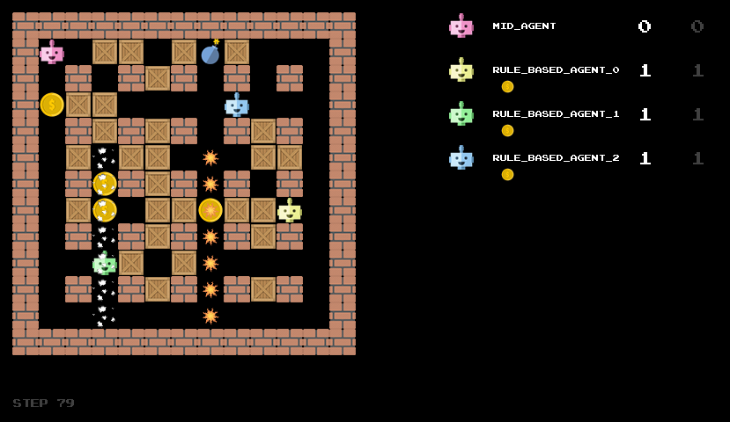
Figure 4: Rule base agent
- Use BFS to Plant bomb on target and picked coin
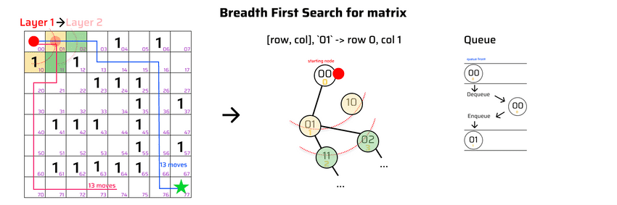
Figure 5: BFS Algorithm
- Go random square nearby to Dodge bombs
- Features

4.1. Feature type 1
Features are what egent uses for based on to act something on environment.
In this bomberman, there are many ways to pick a feature. The first feature we used is a square around the agent with radius (offset) = 2
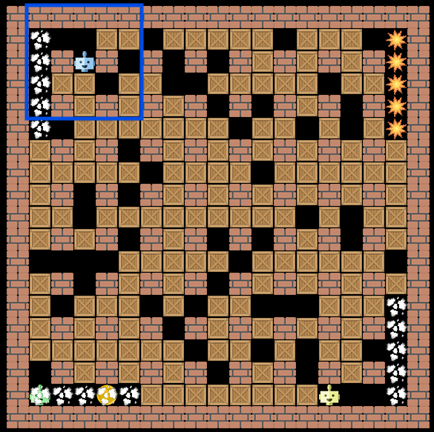
Figure 6: Features type 1
After train the agent (1000 round) with these features, model seem like not tend to study how to win:
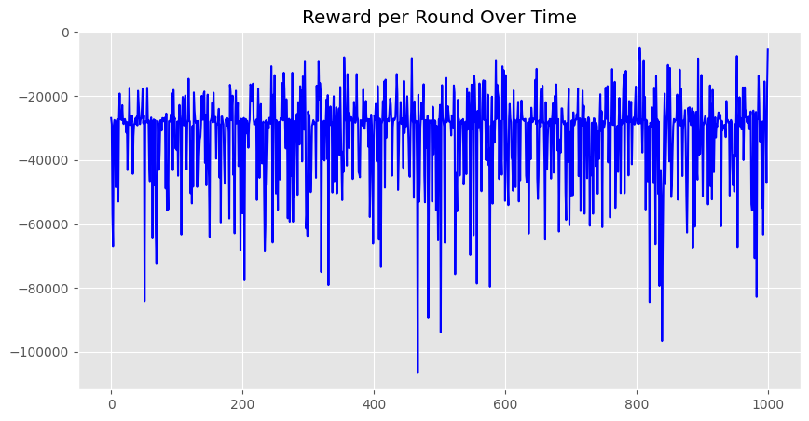
Figure 7
When using the first feature, q table was implemented by a dict(). It is mean trade-off between code simplicity and data accessibility. Here, although the implementation would be quite easy, but with the nature of dictionaries in python, the data access time will be O(logn) and model was larger. The figure below is the hashing fuction, which convert features into dictionary key:
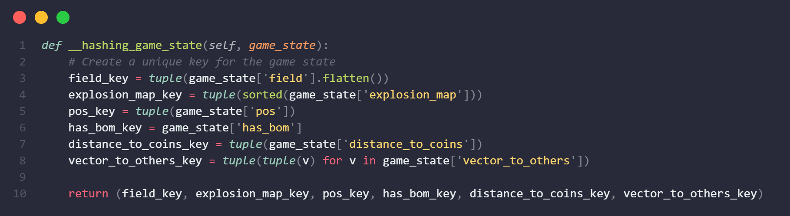

4.2.Feature type 2
The next feature we used a cross with each side length being 5. The dimension of data was decrease (about 7.5 times)
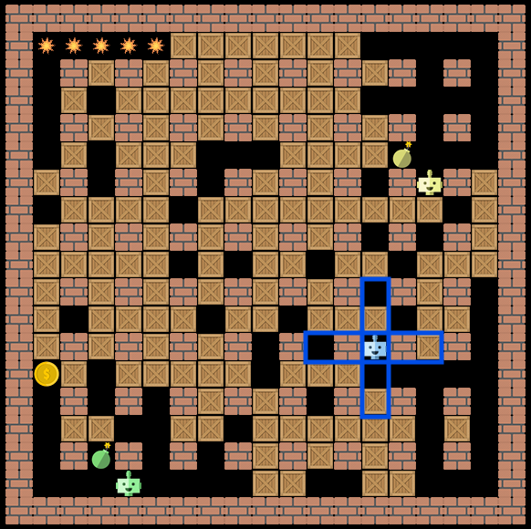
Figure 8: Features type 2
After train within 1000 round, It seems that the model did not learn very well, but the results were slightly better than type 1:
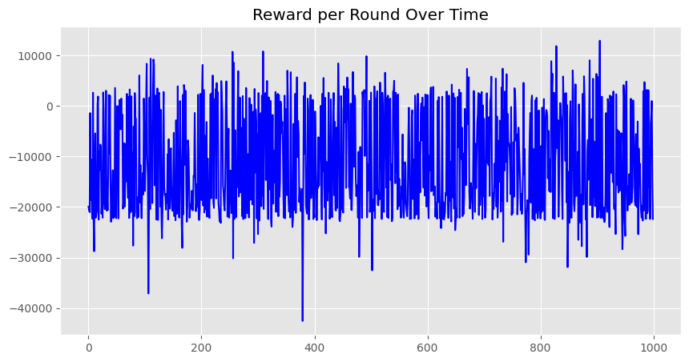

4.3 Feature Type 3
At type 3, we use the same feature as type 2 but with some improvements. That is adding vector to nearest opponent and some representation of bomb placement ability.
Dictionary is replaced by 2D array, it makes model increase accessibility, reduce time complexity.
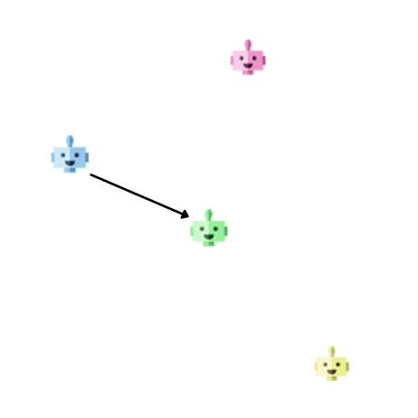
Figure 9: Vector to the closest
Train within 1000 round. Score is low, the agent seems to learn nothing.
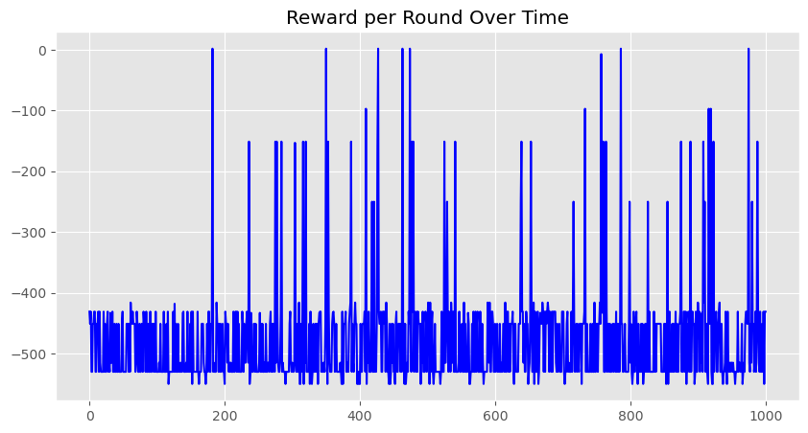
The state space of the Bomberman game is extremely large and complex due to many interacting elements, such as walls, bombs, enemies, power-ups, and dynamic changes in the environment over time.
As a result, using a traditional Q-table approach becomes impractical, because it would require storing and updating an enormous number of state-action values, many of which may never be visited during training.
This leads to extremely slow or even stagnant learning, as the agent cannot generalize well and has to rely on exact state matches.
Therefore, the agent is unable to learn meaningful behaviors using a Q-table, especially in such a high-dimensional and sparse environment.
- Neural Network
  - Theory
In this step, we utilize a neural network (NN) to train the agent. This neural network comprises a single fully connected layer.
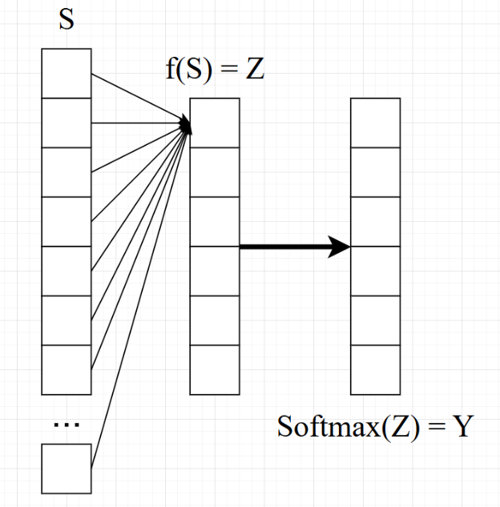
Figure 10: Neural network
- Input: The input to this layer is a feature (state) vector: s.
- Output: The output of this fully connected layer is a 6x1 vector, representing the number of actions the agent can take.
- Activation Function: This output vector is then fed into a softmax function to produce a probability distribution over the actions, where each value represents the probability of a specific action.

Denote as formolar:
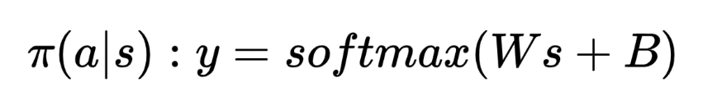
Where:
- π(a∣s) is the probability of action a given state s.
- y is the output probability vector.
- W is the weight matrix of the fully connected layer.
- s is the input state vector.
- B is the bias vector.
- softmax is the function that normalizes the output into a probability distribution.
To update the weights (W) and biases (B) of the neural network, we employ the Policy Gradient method. This method seeks to find the optimal policy π — a probability distribution for choosing action a in state s, with parameters θ={W,B} for an entire episode.
Our objective is to maximize the objective function J(θ), defined as the expected total discounted return over an episode:
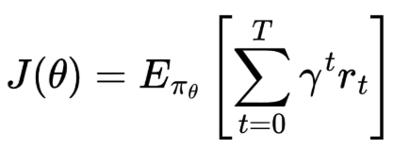
Where:
- E​​ denotes the expectation taken under policy π with parameters θ.
- γ is the discount factor.
- r​ is the reward received at time t.
- T is the length of the episode.
What we need to do is maxima this J(θ). To achieve the maximization of J(θ), we use the Gradient Ascent method to update the parameters θ according to the formula:
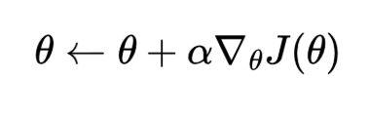
  - Implement
To calculate the gradient of J(𝜃), we use derivative trick:
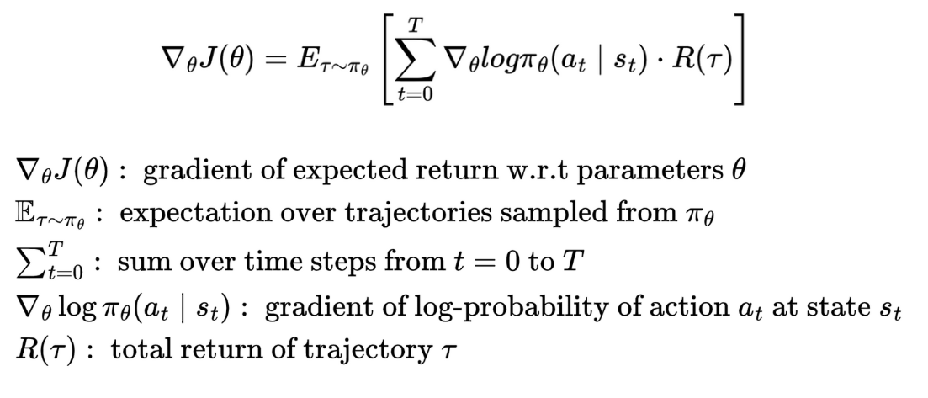
Training agent which is using neural network with three rule_based_agent, 1000 round.
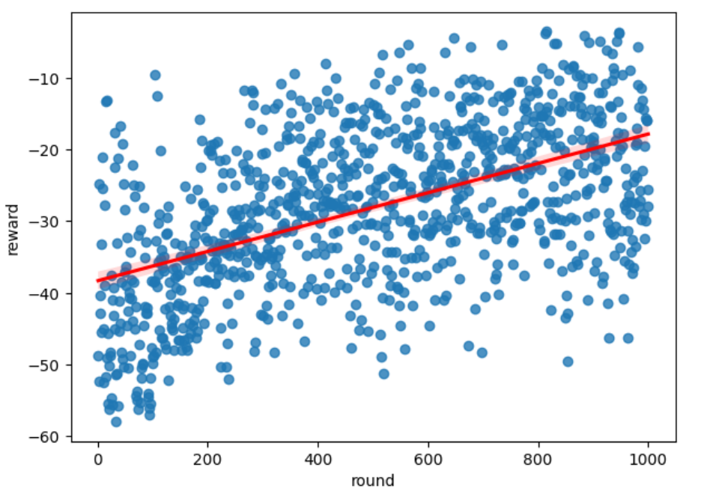
Deeping in the plot, it seems like agent turn to learn something. Although the score is still negative, the agents improve with each epoch.
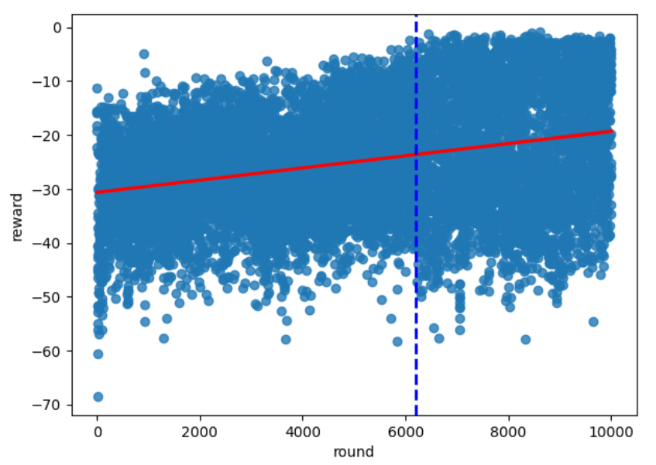
Up to 50.000 rounds, the agent is improving, but not by much. The reward variation is still quite large. From around round 6000 onwards, the agent doesn't seem to learn anything.
→ One layer of neural network is effective, it make agent learn some thing but not enought.
- Conclution
Instead of training the agent by letting it play with a human, I implemented a rule-based agent to serve as an opponent during training.
Due to the extremely large state space of the Bomberman game, using a Q-table was infeasible, so I applied a simple neural network to approximate the action policy.
However, despite some improvements, the trained agent only showed limited progress, likely due to the simplicity of the network and training strategy.

